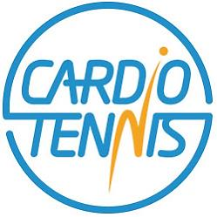

CARDIO TENNIS – AUTUMN 2022

Monday Evenings: 6.30 – 7.30pm
Tuesday Mornings: 9.30 – 10.30am
Friday Afternoons: 1.30 – 2.30pm

Term Dates:
Monday – 14 weeks: 5 Sept – 12 Dec (no coaching 24 Oct ½ term)
Tuesday – 14 weeks: 6 Sept – 13 Dec (no coaching 25 Oct ½ term)
Friday – 14 weeks: 9 Sept – 16 Dec (no coaching 28 Oct ½ term)

Ref | Session | Category | Member Cost* | Non-Member Cost** | Book Online
165 | Mon 6.30 – 7.30pm | Cardio Tennis | £98.00 | £126.00 | Click to book HERE
166 | Tues 9.30 – 10.30am | Cardio Tennis | £98.00 | £126.00 | Click to book HERE
167 | Fri 1.30 – 2.30pm | Cardio Tennis | £98.00 | £126.00 | Click to book HERE

To benefit from discounted adult member coaching fees, you must be a current member of the club.
**Bookings will be checked by our coaching administrator to ensure that correct fee has been paid.

Click the link above to book or contact
Dane Marshall 07875 707 173
email wokinghamtenniscoaching@gmail.com

